**SMART WATER SYSTEM**

**Objectives:**

A Smart Water System is designed to improve the management and conservation of water resources through the use of advanced technology and data analytics. The objectives of implementing such a system can vary depending on the specific goals and needs of the community or organization, but here are some common objectives:

**Water Conservation**: One of the primary objectives of a Smart Water System is to promote water conservation. By monitoring water usage in real-time and identifying leaks or wasteful practices, the system can help reduce water consumption and minimize water loss.

**Efficient Water Distribution**: Smart Water Systems aim to optimize the distribution of water by monitoring the flow of water through pipes and adjusting it according to demand. This helps in reducing energy costs and ensures that water is distributed efficiently.

**Leak Detection and Prevention**: Detecting leaks in the water distribution network is crucial for preventing water loss and infrastructure damage. Smart Water Systems use sensors and data analytics to identify leaks early and take corrective actions.

**Data-driven Decision Making:** These systems provide valuable data and insights about water usage patterns, which can be used for informed decision making. Water utilities and municipalities can use this data to plan for infrastructure upgrades, set pricing policies, and develop strategies for water resource management.

**Customer Engagement**: Smart Water Systems often include features that allow customers to monitor their water usage in real-time through apps or web portals. This not only empowers customers to manage their water consumption but also encourages water conservation.

**Improved Water Quality**: Monitoring water quality in real-time is essential for ensuring that the water supply is safe for consumption. Smart Water Systems can detect contaminants and issues with water quality promptly, allowing for rapid response and corrective actions.

**Reduction of Operational Costs:** By automating many aspects of water management, such as meter reading, leak detection, and valve control, Smart Water Systems can reduce operational costs for water utilities.

**Resilience and Disaster Response:** These systems can enhance the resilience of the water supply infrastructure by providing early warning systems for natural disasters, ensuring that emergency responses are quicker and more effective.

**Sustainability:** Implementing a Smart Water System aligns with sustainability goals by reducing water waste and improving the overall efficiency of water resource management. It contributes to the conservation of this valuable resource.

**Compliance and Regulatory Requirements**: Many regions have strict regulations and standards related to water management and quality. Smart Water Systems can help utilities and organizations meet these regulatory requirements by providing accurate data and monitoring capabilities.

**Long-term Planning**: Smart Water Systems can assist in long-term planning for water resource management, helping communities adapt to changing environmental conditions and population growth.

**Infrastructure Maintenance**: These systems can help prioritize infrastructure maintenance by providing data on the condition of pipes, pumps, and other equipment. This proactive approach can extend the life of infrastructure and reduce costly emergency repairs.

The specific objectives of a Smart Water System will depend on the goals of the organization or community implementing it, as well as the available technology and resources. However, these objectives generally focus on improving the efficiency, sustainability, and reliability of water management while reducing waste and costs.

**IoT sensor setup:**

Setting up a smart water system with IoT sensors involves several steps, from selecting the right sensors to configuring the network and implementing data analytics. Below is a general outline of how to set up an IoT-based smart water system:

**1. Define Your Objectives:**

* Determine the specific goals and objectives of your smart water system. What data do you want to collect, and what problems are you trying to solve? Examples include monitoring water quality, managing water usage, and detecting leaks.

**2. Select Sensors:**

* Choose appropriate sensors for your application. Common sensors for a smart water system may include:
  + Water quality sensors (pH, turbidity, dissolved oxygen, etc.)
  + Flow meters
  + Pressure sensors
  + Temperature sensors
  + Water level sensors
  + Leak detectors

**3. Network Connectivity**:

* Decide on the communication technology you'll use to connect the sensors to your IoT platform. Options include Wi-Fi, cellular, LoRaWAN, or NB-IoT. Choose the one that suits your location and data transmission needs.

**4. IoT Platform:**

* Select an IoT platform or cloud service to collect, store, and analyze the data from your sensors. Popular choices include AWS IoT, Azure IoT, Google Cloud IoT, or platform-agnostic options like MQTT.

**5. Sensor Deployment:**

* Install and configure your sensors in the desired locations. Ensure they are properly calibrated and powered. Be mindful of the environmental conditions and power requirements of each sensor.

**6. Data Collection:**

* Set up data collection mechanisms to gather sensor data and transmit it to your IoT platform. This may involve configuring data loggers, gateways, or microcontrollers to interface with the sensors.

**7. Data Storage:**

* Store the collected data securely on your IoT platform or in a database. Implement data retention policies and backups to ensure data integrity.

**8. Data Analysis and Visualization:**

* Use analytics tools to process and analyze the collected data. Create dashboards or reports for real-time monitoring and historical analysis. Tools like Grafana, Tableau, or custom web applications can be used for visualization.

**9. Alerts and Notifications:**

* Configure alerts and notifications based on predefined thresholds or anomaly detection algorithms. This allows you to respond quickly to critical events like leaks or water quality issues.

**10. Maintenance and Monitoring: -** Regularly maintain and calibrate sensors to ensure accurate data. Implement a monitoring system to track the health of your IoT devices and address any issues promptly.

**11. Scalability: -** Consider future scalability requirements. As your system expands, you may need to add more sensors, gateways, or processing power to handle increased data loads.

**12. Compliance and Regulations: -** Ensure that your smart water system complies with local regulations and standards for water monitoring and data privacy.

**13. Security: -** Implement robust security measures to protect your IoT system from cyber threats. This includes encryption, authentication, and access control.

**14. Data Integration: -** If necessary, integrate your IoT water system with other systems, such as water treatment plants, utility management systems, or customer billing systems.

**15. User Interface and Accessibility: -** Provide user-friendly interfaces for administrators and end-users to access and interact with the data and system. This may involve developing mobile apps or web portals.

**16. Training and Documentation: -** Train personnel on how to use and maintain the smart water system. Create documentation for troubleshooting and system administration.

**17. Continuous Improvement: -** Regularly review the performance of your smart water system and make improvements based on data analysis and feedback.

Remember that the specific details of setting up your IoT-based smart water system will depend on your unique requirements and constraints, so adapt the above steps accordingly.

**Mobile app development:**

**Developing a mobile app for a smart water system can provide users with convenient access to real-time data, control over water-related functions, and the ability to receive alerts and notifications. Here are the steps to develop a mobile app for a smart water system:**

**1. Define App Objectives and Features:**

**Clearly define the objectives of your mobile app. Identify the key features you want to offer to users, such as monitoring water quality, managing water usage, detecting leaks, setting preferences, and receiving alerts.**

**2. Choose App Platforms:**

**Decide whether you want to develop a native app (iOS and Android) or a cross-platform app using technologies like React Native or Flutter. Your choice may depend on your target audience and development resources.**

**3. Design User Interface (UI):**

**Create wireframes and design the user interface (UI) of the app. Ensure the design is user-friendly, intuitive, and visually appealing. Pay attention to the user experience (UX) to make navigation smooth.**

**4. Develop App Backend:**

**Set up the backend infrastructure to handle data storage, user authentication, and communication with the smart water system's IoT platform. You may need to use cloud services like AWS, Azure, or Google Cloud for this.**

**5. Data Integration:**

**Integrate the mobile app with the IoT platform or data storage system to fetch real-time sensor data, historical data, and configuration settings.**

**6. User Authentication and Security:**

**Implement user authentication mechanisms to ensure only authorized users can access the app. Implement robust security measures to protect user data and communication.**

**7. Real-time Data Visualization:**

**Develop the functionality to display real-time data from sensors, such as water quality metrics, water flow rates, and water levels. Use charts, graphs, and maps to present data visually.**

**8. Alerts and Notifications:**

**Implement a notification system to alert users about critical events, such as leaks, water quality issues, or unusual consumption patterns. Push notifications can be a valuable feature.**

**9. User Control and Settings:**

**Allow users to control certain aspects of the smart water system through the app, such as adjusting water flow, setting consumption limits, or scheduling tasks.**

**10. Offline Mode:**

**Ensure that the app can function in offline mode or under poor network conditions. Users should be able to access some essential functions even without an internet connection.**

**11. Testing and Quality Assurance:**

**Thoroughly test the app for functionality, usability, and security. Identify and fix any bugs or issues. Consider beta testing with a small group of users to gather feedback.**

**12. Compliance and Data Privacy:**

**Ensure that your app complies with relevant data privacy regulations (e.g., GDPR) and security standards. Clearly communicate your privacy policy to users.**

**13. App Deployment:**

**Deploy the app to the respective app stores (Apple App Store, Google Play Store) or distribute it through other channels if required.**

**14. Maintenance and Updates:**

**Continuously monitor and maintain the app. Regularly release updates to improve functionality, fix bugs, and enhance security. Address user feedback and feature requests.**

**15. User Support and Documentation:**

**Provide user support channels and create documentation or in-app help guides to assist users in using the app effectively.**

**16. Marketing and User Adoption:-**

**Develop a marketing strategy to promote the app and encourage user adoption. Consider offering incentives or discounts to early adopters.**

**17. Feedback and Iteration:**

**Encourage users to provide feedback and use it to iterate and improve the app over time.**

**Developing a mobile app for a smart water system can be a complex project, so it's important to plan carefully and engage with users to ensure that the app meets their needs and expectations. Additionally, consider future scalability and compatibility with evolving IoT technologies and sensors.**

**Raspberry Pi integration:**

Integrating a Raspberry Pi into a smart water system can provide a versatile and cost-effective way to gather, process, and transmit data from sensors and control various aspects of the system. Here's a guide on how to integrate a Raspberry Pi into a smart water system:

**1. Raspberry Pi Selection:**

* Choose the appropriate Raspberry Pi model for your project, considering factors like processing power, connectivity options, and power requirements. The Raspberry Pi 4 or later models are typically good choices for IoT applications.

**2. Sensor Integration:**

* Connect the water sensors (e.g., water quality sensors, flow meters, level sensors) to the GPIO pins or use suitable interfaces like I2C, SPI, or USB. Install any necessary libraries or drivers to interface with the sensors.

**3. Power Supply:**

* Ensure a stable power supply for the Raspberry Pi and sensors. You may need to use an external power source or a UPS (Uninterruptible Power Supply) to prevent data loss during power outages.

**4. Data Acquisition:**

* Write Python scripts or use suitable programming languages (e.g., Python, Node.js) to read data from the sensors connected to the Raspberry Pi. Store the data locally or send it to a remote server or cloud platform for further processing.

**5. Data Processing:**

* Implement data processing logic on the Raspberry Pi if necessary. You can perform calculations, apply filters, or aggregate data before sending it to a centralized system for storage and analysis.

**6. Communication:**

* Establish communication with your IoT platform or cloud service of choice. Options include MQTT, HTTP, or other relevant protocols. Ensure that the Raspberry Pi can securely transmit data over the internet using encryption and authentication.

**7. Security:**

* Implement security measures on the Raspberry Pi to protect against unauthorized access and data breaches. Consider using encryption for sensitive data and firewall rules to restrict network access.

**8. Remote Access:**

* Set up remote access to the Raspberry Pi for maintenance and troubleshooting. Tools like SSH (Secure Shell) or VNC (Virtual Network Computing) can be used for remote management.

**9. Logging and Error Handling:**

* Implement robust logging and error handling mechanisms on the Raspberry Pi to facilitate debugging and troubleshooting. This can help you identify issues quickly.

**10. Alerts and Notifications:** - Implement a mechanism to generate alerts and notifications based on sensor data. You can use email, SMS, or push notifications to alert stakeholders about critical events.

**11. User Interface (Optional):** - Develop a web-based or mobile user interface for monitoring and controlling the smart water system. Flask, Django, or Node.js can be used to create a web application. Use libraries like Bootstrap for frontend design.

**12. Testing:** - Thoroughly test the Raspberry Pi integration, including sensor data accuracy, communication reliability, and system responsiveness.

**13. Deployment:** - Deploy the Raspberry Pi in the desired location within your smart water system. Ensure it is securely mounted, adequately powered, and has reliable network connectivity.

**14. Maintenance and Updates:** - Regularly update the Raspberry Pi's software and libraries to ensure security and performance. Implement a backup strategy for critical data.

**15. Scalability:** - Plan for scalability by considering how you will add more sensors or Raspberry Pi devices as your smart water system expands.

**16. Compliance and Regulations:** - Ensure that your Raspberry Pi integration complies with any local regulations or standards for water monitoring and data privacy.

Remember that the specific details of integrating a Raspberry Pi into your smart water system will depend on your unique requirements and the sensors you are using. Carefully document your setup and processes to facilitate maintenance and troubleshooting.

**Code implementation:**

**import paho.mqtt.client as mqtt**

**import time**

**# Define MQTT parameters**

**broker_address = "mqtt.example.com"**

**port = 1883**

**topic = "water_sensor_data"**

**# Initialize MQTT client**

**client = mqtt.Client()**

**client.connect(broker_address, port)**

**while True:**

**# Read data from sensors (replace with your sensor code)**

**water_level = read_water_level_sensor()**

**water_quality = read_water_quality_sensor()**

**# Create a JSON payload**

**payload = {**

**"water_level": water_level,**

**"water_quality": water_quality**

**}**

**# Publish data to the MQTT topic**

**client.publish(topic, json.dumps(payload))**

**# Wait for a specific interval before taking the next reading**

**time.sleep(60) # Adjust as needed**

**APPLICATION CODE:**

**import time**

**import random**

**# Simulated sensor data (replace with actual sensor readings)**

**def read_water_flow_sensor():**

**return random.uniform(0.1, 5.0) # Simulate flow rate (in gallons per minute)**

**def read_water_quality_sensor():**

**return random.uniform(6.0, 8.5) # Simulate pH level**

**# Function to control water-related devices (e.g., pumps, valves)**

**def control_water_devices(flow_rate, pH_level):**

**# Implement your control logic here**

**# Example: Turn off the pump if pH is too low or flow rate is too high**

**if pH_level < 6.5 or flow_rate > 4.0:**

**print("Turning off the pump")**

**# Implement code to control the pump (e.g., GPIO output)**

**# Main application loop**

**while True:**

**try:**

**# Read sensor data**

**flow_rate = read_water_flow_sensor()**

**pH_level = read_water_quality_sensor()**

**# Print sensor data (replace with actual data processing)**

**print(f"Water Flow Rate: {flow_rate} GPM")**

**print(f"pH Level: {pH_level}")**

**# Implement your data processing and control logic**

**control_water_devices(flow_rate, pH_level)**

**# Delay between readings**

**time.sleep(10) # Adjust as needed**

**except KeyboardInterrupt:**

**break**

**# Clean up any GPIO or other resources as needed**

**Diagram:**

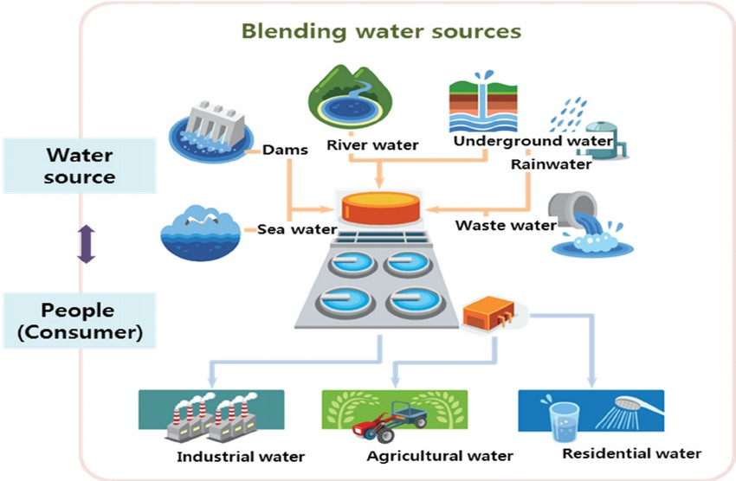

**Schematic diagram:**

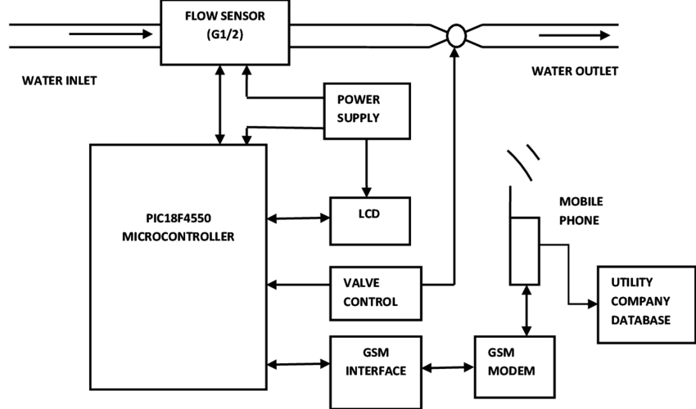

**Explain how the real-time water consumption monitoring system can promote water conservation and sustainable practices.**

A real-time water consumption monitoring system in a smart water system can significantly promote water conservation and sustainable practices by providing valuable data, insights, and tools to both consumers and water management authorities. Here's how such a system can contribute to water conservation and sustainability:

1. **Awareness and Accountability:**
   * Real-time monitoring makes consumers and water users aware of their water consumption patterns. When people can see how much water they are using in real-time, they tend to be more conscious of their habits and are more likely to reduce wasteful practices.
2. **Leak Detection and Early Intervention:**
   * The system can quickly identify leaks and abnormalities in water usage patterns. When a leak is detected, users can be alerted immediately, allowing for swift repairs. This prevents water wastage and property damage.
3. **Usage Optimization:**
   * Users can access historical data and usage trends, helping them understand when and how they use water most. Armed with this information, they can make informed decisions about how to optimize their water consumption.
4. **Remote Control and Automation:**
   * Some smart water systems allow users to remotely control water-related devices, such as irrigation systems or water heaters. Users can adjust settings based on real-time data or preset schedules to avoid unnecessary water usage.
5. **Incentivizing Conservation:**
   * Water management authorities can use the data to implement water conservation incentives and pricing models. For example, tiered pricing can encourage responsible usage by charging higher rates for excessive consumption.
6. **Demand Response:**
   * Utilities can use real-time data to manage water supply and demand more efficiently. During periods of high demand or water scarcity, they can implement demand response strategies to reduce water usage or redistribute resources.
7. **Environmental Impact Reduction:**
   * By conserving water, the system helps protect local ecosystems, reduces the energy required for water treatment and distribution, and minimizes the environmental impact of wastewater discharge.
8. **Infrastructure Optimization:**
   * Water management authorities can make data-driven decisions about infrastructure investments. For example, they can identify areas with consistently high water demand and plan for infrastructure upgrades accordingly.
9. **Education and Outreach:**
   * Real-time water consumption data can be used in educational campaigns and outreach efforts to raise awareness about water conservation. Users can be provided with tips and recommendations on how to reduce their water footprint.
10. **Compliance with Regulations:**
    * Water utilities and industries can use real-time monitoring to ensure compliance with water usage regulations and environmental standards, reducing the risk of fines and penalties.
11. **Emergency Response:**
    * In case of water shortages or contamination events, real-time monitoring can help authorities respond quickly to protect public health and safety.
12. **Data-Driven Decision-Making:**
    * Water utilities can use data analytics to make informed decisions about water management, infrastructure investments, and resource allocation.

In summary, a real-time water consumption monitoring system empowers individuals and organizations with data and insights that enable them to make more sustainable choices and reduce water waste. By promoting responsible water usage, preventing leaks, and improving water resource management, such a system plays a vital role in conserving water and contributing to long-term sustainability in the face of growing water scarcity and environmental challenges.